A000-AM,C-Costa Rica-Vessel Leg Fragment-300-800 CE

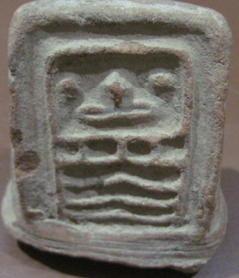

Case No.:

**Accession No.**

**Formal Label:**

**Display Description:**

**LC Classification:**

**Date or Time Horizon:**

**Geographical Area:**

**Map:**

**GPS coordinates:**

**Cultural Affiliation:**

**Media:**

**Dimensions:**

**Weight:**

**Condition:**

**Provenance:**

**Discussion:**

**References:**

Pre-Columbian Terracotta Vessel leg fragment with traditional head figure  9.1cm x 7.8cm x 5.9cm some trace of original paint Costa Rica..Circa 300-800AD   
from a large Tucson Arizona Professors Collection  
 collected in the 1950"s **CAA-16**   
Authenticity is guaranteed